Northwest Connection Family Resources

Annual Fall Child Care Provider Conference

**Celebrate PLAY**

**Join us for a fun filled day of PLAY! Lisa is back by popular demand. If you attended the conference in 2021 you know you’re in for a good time… if you didn’t *DON’T MISS OUT* again. Register early for the best rate.**

**Lisa Murphy aka: the Ooey Gooey Lady®!**

**October 21, 2023**

**Registration begins 8:00 am**

**Morning coffee & Networking 8:00 – 9:00 am**

**Conference 9:00 am – 4:00 pm**

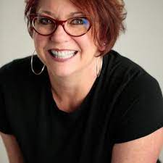

Lisa Murphy, M.Ed., Early Childhood Specialist Founder and CEO of Ooey Gooey, Inc. Lisa Murphy has been involved in Early Care and Education (ECE) for over 35 years; she is the oldest of five, grew up in a family child care home and eventually moved from being the neighborhood babysitter to being a nanny for many families while attending college in Chicago. She has spent most of her adult/professional life working with children in various environments including Head Start, public elementary schools, child care centers, family child care homes, Park and Rec Centers and Boys and Girls Clubs. Lisa is the founder and CEO of Ooey Gooey, Inc. where her mission is to assist in the transformation of the industry of early childhood education by offering 1) the best workshops and trainings; 2) the most up to date materials and resources; and 3) insightful conversations and connections through the power of social media. Lisa presents hundreds of workshops each year to both domestic and international audiences on various topics related to ECE. Lisa has an M.Ed. (2013) in early childhood education from Champlain College in Vermont. She has authored five books, produced dozens of teacher training DVD’s, is a popular keynote speaker at educational conferences and a frequent guest on many early childhood related podcasts. Her standing room only seminars have become known for their relevant information, humor, inspiration and energetic delivery. Frequently asked if she has ever been a stand up comic, Lisa practices what she preaches as she blends the learning with the laughing. Lisa is known for her candid delivery style, her ability to link hands-on activities to educational standards, her outspoken advocacy, and her commitment to creating child-centered, play-based early childhood environments. Her understanding of the importance of play is obvious in her personal and professional life. Lisa grew up in California but has lived all over the USA. She currently calls Central Florida home where she lives with her boyfriend Pablo and two fur babies, Kane and Zoe. When she's not doing ECE gigs you will find her taking long walks, reading, or cooking up a storm and posting foodie pics on Instagram.

**WELCOME & ANNOUNCEMENTS**

MANY KINDS OF SMART!

**Understanding Multiple Intelligences Theory**

**KEYNOTE:** Think you are good at your job because you love children? What about the ones that challenge you? Using these powerful questions as a framework, Lisa puts her own spin on Howard Gardner’s classic theory. This session is a far cry from simply listing various personality characteristics, needs and preferences. By providing easy to implement, yet possibly challenging, “comfort zone stretchers,” Lisa challenges teachers to make sure they are celebrating all of the children in the classroom, not just the ones they like.

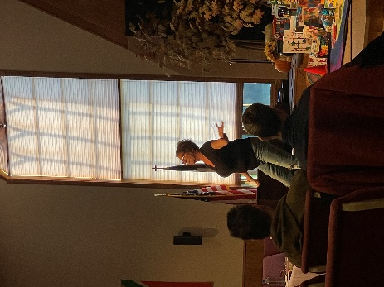**BEING CHILD CENTERED!**

**MORNING SESSION:** This workshop is the workshop version of the content in her latest book: Lisa Murphy On… Being Child Centered. This session provides an in-depth exploration of the NINE POINTS within the framework of Lisa Murphy’s approach to working with children. Via interactive lecture, true-to-life examples, anecdotes and her signature “learning and laughing” style, this workshop presents what it really means to be a hands-on, play-based, child-centered program.

**LUNCH & NETWORKING**

LISA MURPHY ON… PLAY!

**The Importance of Early Experiences**

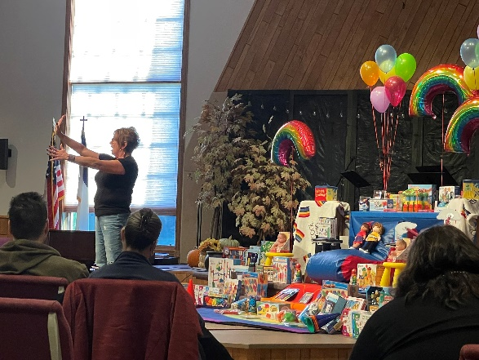**AFTERNOON SESSION:** This is the workshop version of the content contained in Lisa Murphy on… PLAY. In this session Lisa will identify the seven things we need to do with children each day. These seven things make up the foundation that supports the house of higher learning. There is nothing wrong with the “academic” expectations within this house: reading, writing, math… the trouble is that many early childhood educators are being pressured to build a house where there is no foundation. And you do not need to be an architect to know that if you build where there is no foundation, the house will come crashing down! Playing is “getting them ready” and through an investigation of each of the “seven things,” Lisa shows you how. This session has become one of Lisa Murphy’s most popular and oft requested workshops. By making time to create, move, sing, discuss, observe, read and play we are getting children ready not just for kindergarten, but for life!

**DOOR PRIZES**

**FINAL ANNOUNCEMENTS**

**SILENT AUCTION PICK-UP**

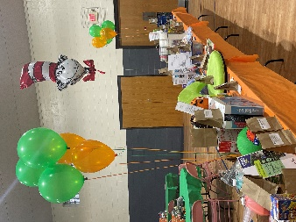

**Connect with friends over morning coffee & lunchtime chats.**

**Conference vendors Silent Auction**

**Door prizes Give-aways Games Laughter**

-----------------------------------------------------------------------------------------------------------------------------------*(pic from last year)*

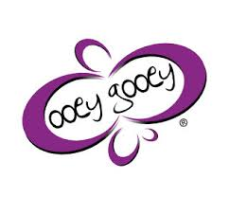**Lisa Murphy – Celebrate PLAY**

**October 21, 2023 9:00 am – 4:00 pm**

**Cost: $35.00 before September 22, 2023**

**$45.00 after September 22, 2023**

***(Payment can be made by PayPal or check)***

***(Registration will be accepted until October 12, 2023 or until the conference is full)***

## To Register online:   <https://forms.gle/dgbzZ9LXxiAqZmDt5>

## To Registry by email: Email [nwconnection@ncfrwi.net](mailto:nwconnection@ncfrwi.net)

## To Register by phone: (800) 733-KIDS

**Name: __________________________________________ Registry # ___________________**

**Program Name: ___________________________________ Phone # ____________________**

**Address: ________________________________________ County/Tribe: ________________**

**Email: ___________________________________________** One form per person.

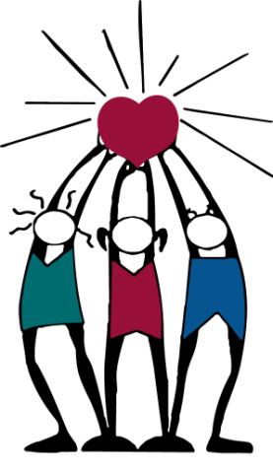

Northwest Connection Family Resources **Bring a non-perishable food item to be donated**

15896 W 3rd Street **to local families and be entered into a drawing.**

Hayward, WI 54843 **$100 Lakeshore gift certificate**

[www.wisconsinchild.org](http://www.wisconsinchild.org)

*(Up to 10 entries – 1 entry per item)*