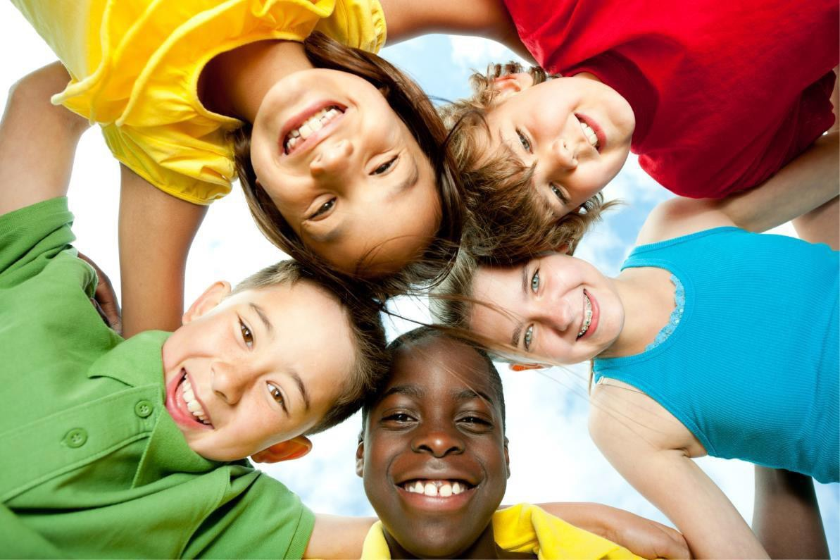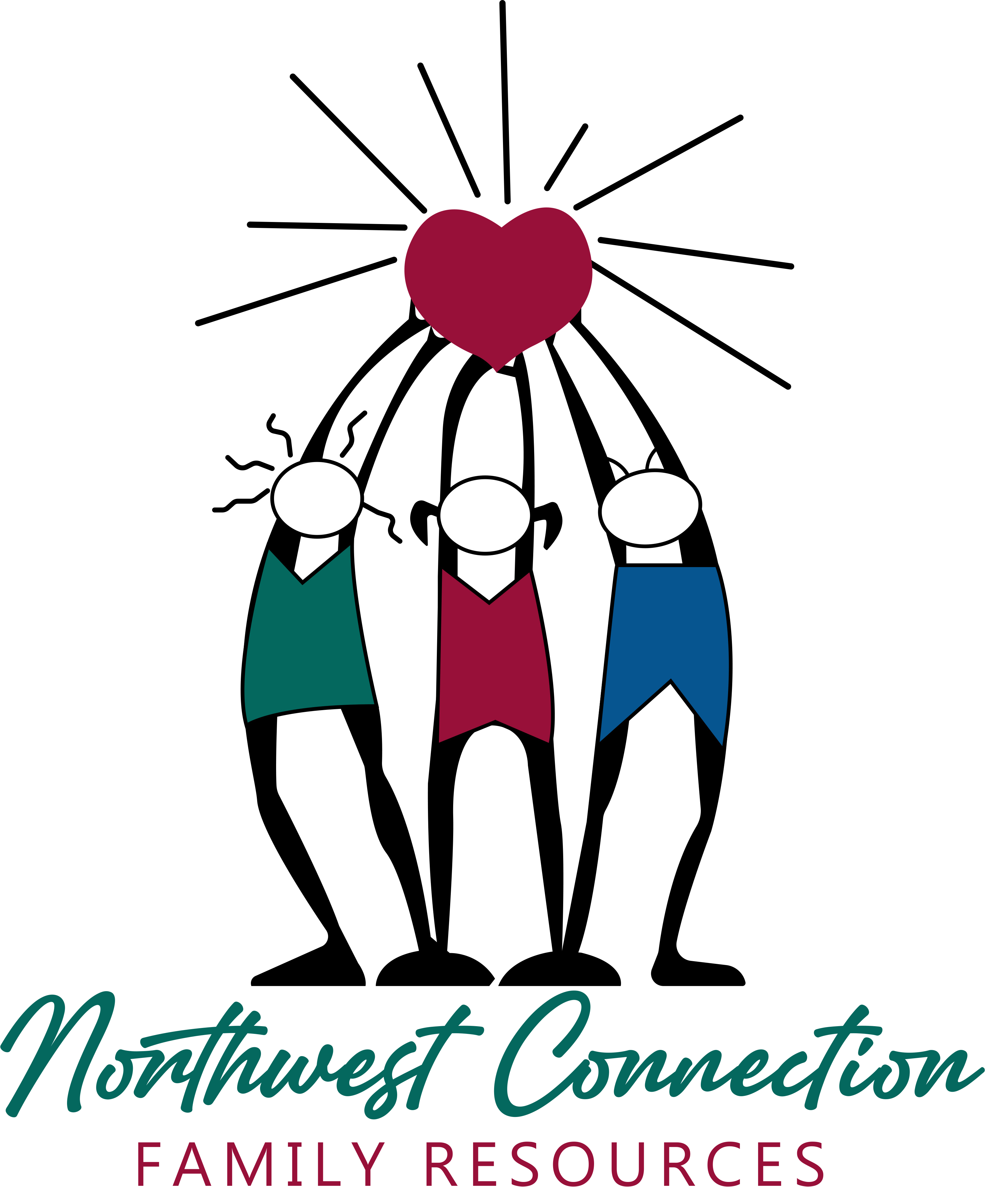

What is Darkness to Light?

This recently **UPDATED** training introduces adults to Darkness to Light’s 5 step program concentrating on preventing, recognizing, and reacting responsibly to child sexual abuse. This training brings awareness about child sexual abuse into the community and empowers adults to take action against this very serious issue. This training includes Mandated Reporter.

**JOIN US FOR THIS SPECIAL EVENT!**

**Tuesday, October 29, 2024**

**6-9 pm - Room 221**

**Northwood Technical College, 1900 College Drive, Rice Lake, WI 54868**

To ensure enough materials, please register by scanning the QR code

or clicking the link at:

**https://forms.gle/SPx1hMb71NjETgBy7**Cost: $15- includes training book (This training is not suitable for children)

**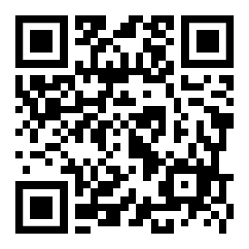*WHY DOES IT APPLY TO ME?*** Child sexual abuse is likely the most prevalent health problem children face, with the most serious array of consequences. In fact, 1 in 10 children will experience sexual abuse before their 18th birthday. This means that whether you work with youth, are a parent, or are simply a member of a community, it is highly likely that someone you know or care for has experienced or is currently experiencing child sexual abuse. It will happen whether you are prepared to deal with it or not – unless you stop it from happening. And the good news, it can be stopped. **REGISTER TODAY!**